
Student Number
Mark / 35

Chemistry

Preliminary Course

Final Examination • 2005

General Instructions

•Reading time – 5 minutes
•Working time – 50 minutes
•Write using black or blue pen
•Draw diagrams using pencil
•Board-approved calculators may be used
•A Data Sheet and a Periodic Table are provided
at the back of this paper and may be removed
for convenience
•Write your Student Number at the top of this page
Total Marks – 35

Part A – 9 marks
•Attempt Questions 1 – 9
•Allow about 10 minutes for this part

Part B – 26 marks
•Attempt Questions 10 – 19
•Allow about 40 minutes for this part

Part A – 9 marks
Attempt Questions 1 – 9
Allow about 10 minutes for this part

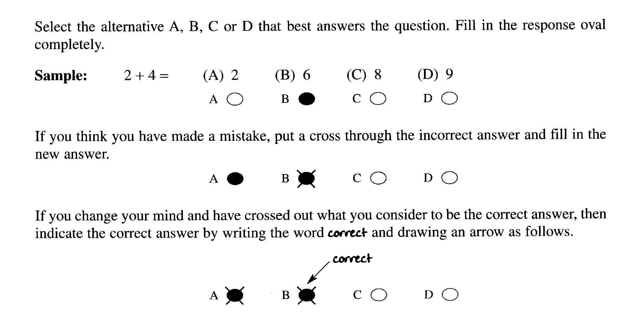

Answer Box for Questions 1 – 9
1 | A ○ | B ○ | C ○ | D ○
2 | A ○ | B ○ | C ○ | D ○
3 | A ○ | B ○ | C ○ | D ○
4 | A ○ | B ○ | C ○ | D ○
5 | A ○ | B ○ | C ○ | D ○
6 | A ○ | B ○ | C ○ | D ○
7 | A ○ | B ○ | C ○ | D ○
8 | A ○ | B ○ | C ○ | D ○
9 | A ○ | B ○ | C ○ | D ○

JRAHS – Chem 11 – Final Examination – 2005 Page 2 of 14

► Mark your answers for Questions 1 – 9 in the Answer Box on page 2.

1 Study the reaction… H₂ _{(g)} + Cl₂ _{(g)} → 2HCl _{(g)}

Which of the statements cannot apply to this reaction?

(A) One gram of H₂ reacts with one gram of Cl₂ to produce 2 grams of HCl.
(B) One molecule of H₂ reacts with one molecule of Cl₂ to produce 2 molecules of HCl.
(C) One litre of H₂ reacts with one litre of Cl₂ to produce 2 litres of HCl at constant conditions.
(D) One mole of H₂ reacts with one mole of Cl₂ to produce 2 moles of HCl.

2 Which of the production sequences shows the extraction of copper from its ore to 99.9% pure copper?

(A) forth flotation → crushing and grinding → smelting → electrolysis
(B) crushing and grinding → froth flotation → smelting → electrolysis
(C) crushing and grinding → smelting → froth flotation → electrolysis
(D) smelting → crushing and grinding → froth flotation → electrolysis

3 Which of the following may not be a consequence of thermal pollution in water?

(A) Reduction in dissolved oxygen.
(B) Disruption of aquatic organisms breeding cycles.
(C) Out of season migration of aquatic fauna.
(D) Decrease in salt concentration.

4 At 100 kPa and 25°C, 4 litres of oxygen gas contain 1 × 10²¹ molecules.
Which of these gas samples also contains 1 × 10²¹ molecules under the same conditions?

(A) 1 L of NH₃
(B) 2 L of Cl₂
(C) 4 L of CO₂
(D) 8 L of He

JRAHS – Chem 11 – Final Examination – 2005 Page 3 of 14

5 To which reaction can Gay–Lassac’s law be applied?

(A) 2H₂ _{(g)} + O₂ _{(g)} → 2H₂O _{(g)}
(B) 2H₂O _{(l)} → 2H₂ _{(g)} + O₂ _{(g)}
(C) 2H₂O _{(l)} + 2Na _{(s)} → 2Na⁺_{(aq)} + 2OH –_{(aq)} + H₂ _{(g)}
(D) H⁺_{(aq)} + OH –_{(aq)} → H₂O _{(l)}

6 Which property accounts for the moderate viscosity of water?

(A) Specific heat capacity
(B) Hydrogen bonding
(C) Density
(D) Boiling point

7 Metals X, M, Z and D are all very useful metals. The table shows selected properties of the metals…

Property | X | M | Z | D
Ionisation energy ( kJ mol ^{– 1} ) | 584 | 751 | 896 | 766
Percentage Abundance in Earth’s Crust | 8 | 0.07 | 0.00001 | 0.07

Use the data to list the metals according to increasing market price.

(A) X < M < D < Z
(B) D < X < Z < M
(C) X < Z < M < D
(D) Z < D < M < X

JRAHS – Chem 11 – Final Examination – 2005 Page 4 of 14

Answer Questions 8 and 9 using this reaction pathway diagram…

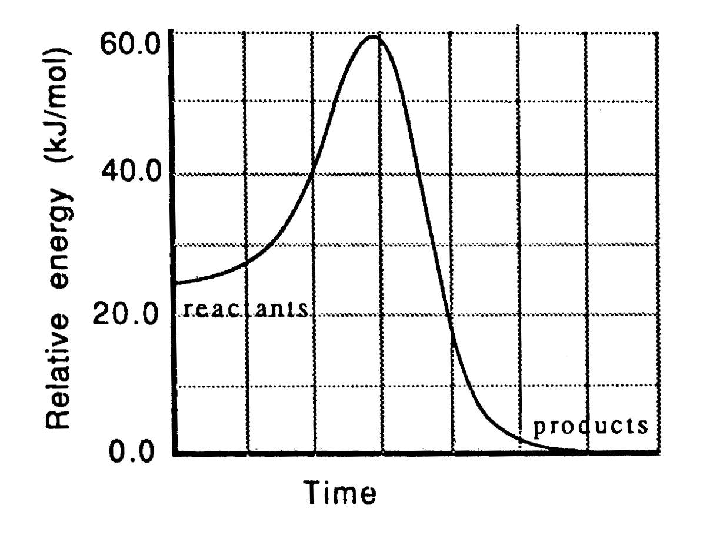

8 Which statement correctly describes this reaction?

(A) The reaction is endothermic and the surroundings will become cooler.
(B) The reaction is exothermic and the surroundings will become cooler.
(C) The reaction is endothermic and the surroundings will become warmer.
(D) The reaction is exothermic and the surroundings will become warmer.

9 Which statement is true if a catalyst is added to the system?

(A) ∆H remains constant and the activation energy increases.
(B) Both ∆H and activation energy decrease.
(C) ∆H remains constant and the activation energy decreases.
(D) Both ∆H and activation energy remain constant.

JRAHS – Chem 11 – Final Examination – 2005 Page 5 of 14

Part B – 26 marks
Attempt Questions 10 – 19
Allow about 40 minutes for this part

► Show all relevant working in questions involving calculations.

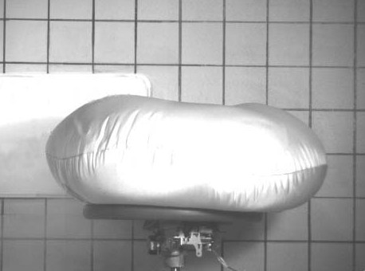
Question 10 (3 marks)

Lab testing of air bag inflation

Air bags have saved thousands of lives and are now commonly fitted in new cars. An air bag inflates very rapidly by producing nitrogen gas from the decomposition of 100 grams of sodium azide…

2NaN₃ _{(s)} → 2Na _{(s)} + 3N₂ _{(g)}

(a) Calculate the moles of sodium azide originally in the air bag. (1 mark)

___________________________________________________________________________________

___________________________________________________________________________________

___________________________________________________________________________________

(b) Calculate the moles of nitrogen produced and the resultant volume at 100 kPa and 25°C. (2 marks)

___________________________________________________________________________________

___________________________________________________________________________________

___________________________________________________________________________________

___________________________________________________________________________________

___________________________________________________________________________________

JRAHS – Chem 11 – Final Examination – 2005 Page 6 of 14

Question 11 (3 marks)

Xenon tetrafluoride is an unstable compound which self–decomposes…

XeF₄ _{(s)} → Xe _{(g)} + 2F₂ _{(g)}

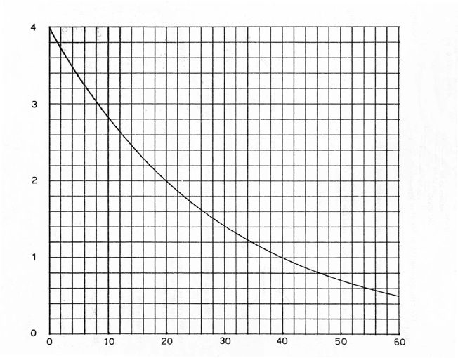
The graph shows the decomposition of a pure, 4 mole sample of XeF₄ over a period of 60 days.

MOLES of XeF₄

TIME (days)

(a) Calculate the number of moles of XeF₄ which has decomposed after 16 days. (1 mark)

___________________________________________________________________________________

(b) On which day are there equal moles of reactant and products present? (1 mark)

___________________________________________________________________________________

(c) Calculate the mass of F₂ present at 40 days. (1 mark)

___________________________________________________________________________________

___________________________________________________________________________________

JRAHS – Chem 11 – Final Examination – 2005 Page 7 of 14

Question 12 (2 marks)

Iron will react with hydrochloric acid and appear to “dissolve” …

Fe _{(s)} + 2HCl _{(aq)} → FeCl₂ _{(aq)} + H₂ _{(g)}

Ken Chemiski places a 2.51 g iron nail in a beaker and prepares some dilute, 1.00 mol L ^{– 1} HCl.

Calculate the volume of acid required to fully react with the nail.

_________________________________________________________________________________________

_________________________________________________________________________________________

_________________________________________________________________________________________

Question 13 (3 marks)

Héloïse prepares some beautiful golden lead(II) iodide crystals by this precipitation reaction…

Pb(NO₃)₂ _{(aq)} + 2KI _{(aq)} → PbI₂ _{(s)} + KNO₃ _{(aq)}

She reacts 25.0 mL of 0.100 mol L ^{– 1} potassium iodide with excess lead(II) nitrate solution.

(a) Calculate the moles of lead(II) nitrate which reacted. (2 marks)

___________________________________________________________________________________

___________________________________________________________________________________

___________________________________________________________________________________

(b) Calculate the mass of PbI₂ produced. (1 mark)

___________________________________________________________________________________

___________________________________________________________________________________

___________________________________________________________________________________

JRAHS – Chem 11 – Final Examination – 2005 Page 8 of 14

Question 14 (3 marks)

In your studies, you performed a practical investigation to observe the effect of temperature on reaction rate. Describe your experiment, including the observed results.

_________________________________________________________________________________________

_________________________________________________________________________________________

_________________________________________________________________________________________

_________________________________________________________________________________________

_________________________________________________________________________________________

_________________________________________________________________________________________

_________________________________________________________________________________________

_________________________________________________________________________________________

_________________________________________________________________________________________

Question 15 (2 marks)

(a) Identify one pollutant produced by the incomplete combustion of an organic compound. (1 mark)

___________________________________________________________________________________

(b) Write a chemical equation to show the incomplete combustion of butane (C₄H₁₀). (1 mark)

___________________________________________________________________________________

JRAHS – Chem 11 – Final Examination – 2005 Page 9 of 14

Question 16 (2 marks)

The diagram shows liquid methanol, CH₃OH, being poured into a beaker of water.

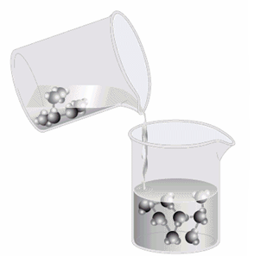

Use the symbols, 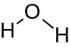 for water and 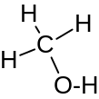 for methanol to draw a diagram that illustrates
the strongest intermolecular forces in the solution.

JRAHS – Chem 11 – Final Examination – 2005 Page 10 of 14

Question 17 (3 marks)

Outline the method required to prepare a 250 mL solution of 0.102 mol L ^{– 1} strontium chloride.
► Write your answer in numbered sequential steps (1, 2, 3…).

_________________________________________________________________________________________

_________________________________________________________________________________________

_________________________________________________________________________________________

_________________________________________________________________________________________

_________________________________________________________________________________________

_________________________________________________________________________________________

_________________________________________________________________________________________

_________________________________________________________________________________________

_________________________________________________________________________________________

_________________________________________________________________________________________

Question 18 (2 marks)

Tincture of iodine, a common antiseptic, is a 2% (w/w) solution of iodine in ethanol.

(a) Calculate the mass of iodine crystals is required to prepare a 250 g sample of tincture of iodine?
(1 mark)

___________________________________________________________________________________

___________________________________________________________________________________

___________________________________________________________________________________

(b) Calculate the mass of ethanol is required? (1 mark)

___________________________________________________________________________________

___________________________________________________________________________________

___________________________________________________________________________________

JRAHS – Chem 11 – Final Examination – 2005 Page 11 of 14

Question 19 (3 marks)

In an experiment to measure the density of water at 28°C, an empty 100 mL measuring cylinder was found to have a mass of 150.5 grams. When 80.3 mL of water was poured into the cylinder, the mass of the cylinder
and contents was 230.5 grams.

(a) Calculate the density of water at 28°C based on the data. (1 mark)

___________________________________________________________________________________

___________________________________________________________________________________

___________________________________________________________________________________

(b) When the measuring cylinder and water was sealed and kept inside a freezer overnight at – 10°C,
the volume reading increased to 85.9 mL. Explain this observation. (1 mark)

___________________________________________________________________________________

___________________________________________________________________________________

___________________________________________________________________________________

___________________________________________________________________________________

(c) When water freezes it expands. Why is this process important in Nature? (1 mark)

___________________________________________________________________________________

___________________________________________________________________________________

___________________________________________________________________________________

JRAHS – Chem 11 – Final Examination – 2005 Page 12 of 14
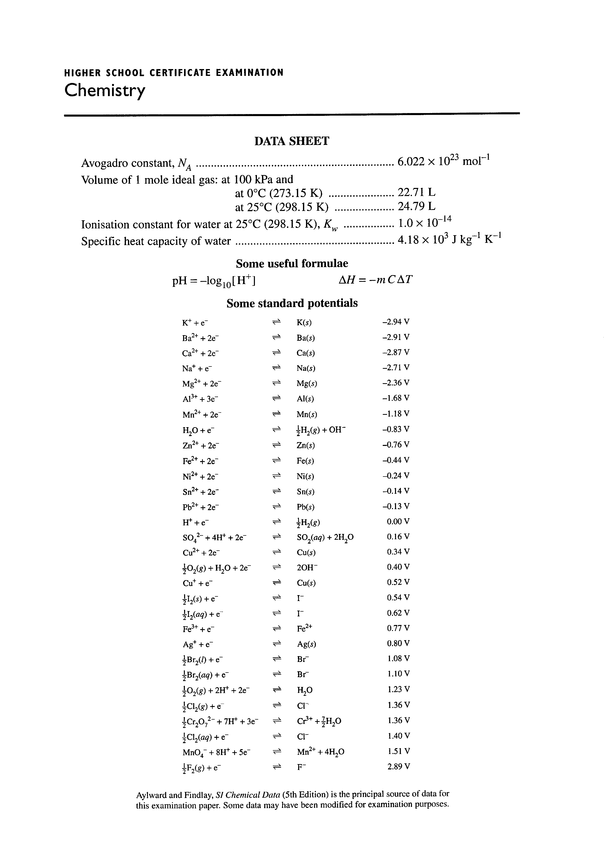
JRAHS – Chem 11 – Final Examination – 2005 Page 13 of 14

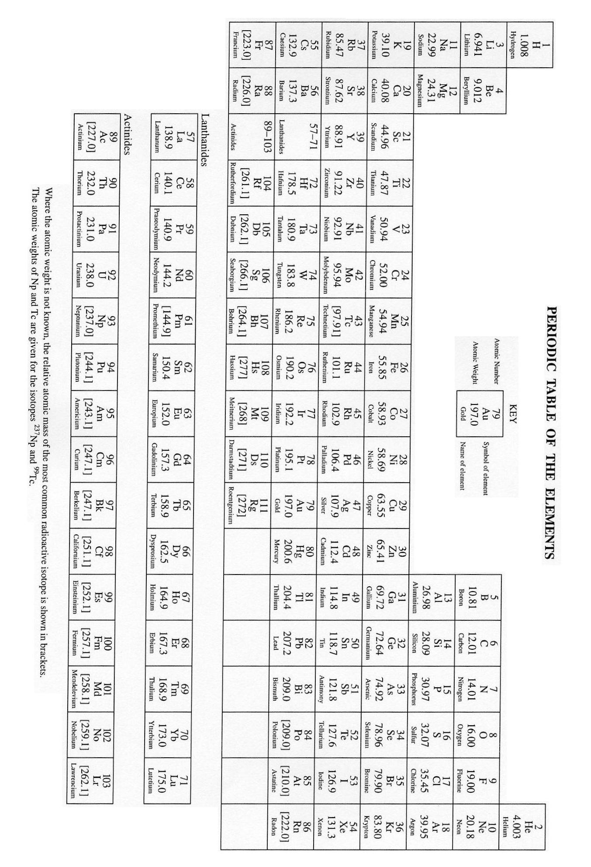

JRAHS – Chem 11 – Final Examination – 2005 Page 14 of 14

